**ONLINE HOTEL RESERVATION SYSTEM**

**(case study of Bano Hotel)**

# TITLE PAGE

**BY**

**BABANGIDA YAHYA**

**(ST/CS/ND/23/164)**

**HAMMAN MARZUQ**

**(ST/CS/ND/23/210)**

**DEPARTMENT OF COMPUTER SCIENCE,**

**SCHOOL OF SCIENCE AND TECHNOLOGY,**

**FEDERAL POLYTECHNIC, MUBI, ADAMAWA STATE.**

**IN PARTIAL FULFILLMENT OF THE REQUIREMENTS FOR THE AWARD OF NATIONAL DIPLOMA (ND) IN COMPUTER SCIENCE.**

**JULY, 2025**

# DECLARATION

We hereby declare that the work in this project titled “**Online Hotel Reservation System (case study of Bano Hotel)**” was performed by us under the supervision of Mal. Muhammad Saleh. The information derived from literature has been duly acknowledged in the text and a list of references provided. The work embodied in this project is original and has not been submitted in part or in full for any other diploma or certificate of this or any other institution.

Babangida Yahya ________________ _______________

(ST/CS/ND/23/164) Signature Date

Hamman Marzuq ________________ _______________

(ST/CS/ND/23/210) Signature Date

# CERTIFICATION

This project titled “**Online Hotel Reservation System (case study of Bano Hotel)**” meets the regulations governing the award of National Diploma (ND) in Computer Science, Federal Polytechnic Mubi, Adamawa State

Mal. Muhammad Saleh __________________

(Project Supervisor) Sign/Date

Mr. Mustapha Kassim. __________________

(Head of Department) Sign/Date

Mal. Abdulrahman Saidu _________________

(External Examiner) Sign/Date

# DEDICATION

This project is dedicated to our beloved parents and love ones for their advice, encouragement and financial support towards our academic pursuit.

# ACKNOWLEDGEMENTS

We want to acknowledge Almighty God for His infinite mercy and protection throughout our academic activities and for granting us understanding in achieving our academic success.

We also recognize our supervisor Mal. Muhammad Saleh, who took time, despite his busy schedule, to direct and guide us throughout this research work.

We acknowledge the Head of the Computer Science Department, Mr. Mustapha Kassim, for his moral encouragement throughout our period of study. We also acknowledge all the staff of the Computer Science Department for their support, encouragement, and the knowledge they have imparted to us throughout our studies.

We appreciate our lovely parents for their love and care and for giving us the opportunity to be trained and achieve our dreams.

Finally, we appreciate the efforts of our uncles and aunties for their encouragement and support throughout the course of our study, as well as our friends, relatives, course mates, and all well-wishers. We love you all. May Almighty God bless you abundantly. Amen.

# TABLE OF CONTENTS

TITLE PAGE i

DECLARATION ii

CERTIFICATION iii

DEDICATION iv

ACKNOWLEDGEMENTS v

TABLE OF CONTENTS vi

LIST OF FIGURES viii

LIST OF TABLES ix

ABSTRACT x

CHAPTER ONE 1

INTRODUCTION 1

1.1 Background to the Study 1

1.2 Problem Statement 2

1.3 Aim and Objectives 2

1.4 Significance of the Study 2

1.5 Scope of the Study 3

CHAPTER TWO 4

LITERATURE REVIEW 4

2.1 Introduction 4

2.2 Online Reservation Systems 4

2.2.1 Features of an Effective Online Hotel Reservation System 5

2.3 Information Management System 7

2.3.1 Importance of Information Management Systems 7

2.4 Database Management System 7

2.5 Related Work 8

CHAPTER THREE 11

SYSTEM ANALYSIS AND DESIGN 11

3.1 Introduction 11

3.2 Disadvantages of the Existing System 11

3.3 Advantages of the Proposed System 11

3.4 Software Development Model 12

3.5 Method of Data Collection 13

3.6 System Design 13

3.6.1 Algorithm Diagram 14

3.6.3 Database Tables/Queries Structures 15

3.6.4 Entity Relationship Modelling 17

3.6.5 Database Entity Relationship Diagram 17

3.6.6 Input and Output Design 18

3.7 System Requirement Specification 20

3.7.1 Hardware Requirements 20

3.7.2 Software Requirements 20

3.7.3 Personnel Requirement 20

CHAPTER FOUR 21

RESULTS AND DISCUSSION 21

4.1 Introduction 21

4.2 Results 21

4.2.3 Home page interface 22

4.2.5 Billing interface 23

4.3 Discussion 25

4.4 User manual 27

4.4.1 System Installation 27

4.4.2 System Operational Guide 27

CHAPTER FIVE 28

SUMMARY, CONCLUSION AND RECOMMENDATIONS 28

5.1 Summary 28

5.2 Conclusion 28

5.3 Recommendations 28

REFERENCES 30

APPENDIX A 31

APPENDIX B 34

# LIST OF FIGURES

Figure 3.1: Waterfall model - - - - - - - - 13

Figure 3.2: Use case diagram- - - - - - - - 14

Figure 3.3: System Architecture - - - - - - - - 15

Figure 3.4: Entity Relationship Modelling - - - - - - 17

Figure 3.5: Database Entity Relationship Diagram - - - - - 17

Figure 3.6: Registration Form - - - - - - - - 18

Figure 3.7: Booking Form - - - - - - - - 18

Figure 3.8: Booking Form - - - - - - - - 18

Figure 3.9: Booking Form - - - - - - - - 19

Figure 3.10: Room Rate - - - - - - - - 19

Figure 4.1: Registration interface - - - - - - - 21

Figure 4.2: Login Interface - - - - - - - - 22

Figure 4.3: Home page interface - - - - - - - 22

Figure 4.4: Booking interface - - - - - - - - 23

Figure 4.5: Billing interface - - - - - - - - 23

Figure 4.6: Booking History Interface - - - - - - 24

Figure 4.7: Reservations Interface - - - - - - - 24

Figure 4.8: Invoice interface - - - - - - - - 25

# LIST OF TABLES

Table 1: Users records - - - - - - - - - 15

Table 2: Room Types Table - - - - - - - - 15

Table 3: Rooms Table - - - - - - - - - 16

Table 4: Bookings Table - - - - - - - - 16

Table 5: Payments Table - - - - - - - - 16

# ****ABSTRACT****

*This project presents the design and implementation of an Online Hotel Reservation System for Bano Hotel, Mubi, aimed at improving the efficiency, accuracy, and accessibility of the hotel’s booking process. The existing manual reservation system, which relies heavily on phone calls and in-person bookings, is prone to human errors, booking conflicts, delays, and record-keeping challenges. To address these shortcomings, a web-based reservation platform was developed using PHP for server-side logic, MySQL for database management, HTML/CSS for user interface design, and JavaScript for interactivity. The system allows customers to register, log in, search for available rooms, make bookings, and view booking history. It also enables hotel staff to manage reservations, track room availability in real-time, generate invoices, and update booking statuses. The design adopts a responsive web layout, ensuring compatibility across various devices and browsers, while maintaining user-friendliness and security. Testing of the system demonstrated that it effectively eliminated overbooking issues, reduced customer wait times, and provided accurate and up-to-date booking information. The system also enhanced customer satisfaction by offering 24/7 accessibility and instant booking confirmation. This project concludes that the adoption of an online reservation system will significantly improve service delivery, operational efficiency, and customer experience at Bano Hotel. Future enhancements could include integrating online payment gateways, mobile application support, and multi-language functionality to further expand the system’s usability and reach.*

*.*

# 

# CHAPTER ONE

# INTRODUCTION

## 1.1 Background to the Study

The hospitality industry, especially the hotel sector, is undergoing a major transformation driven by rapid advancements in Information and Communication Technologies (ICT). The evolution of e-commerce, cloud computing, mobile technologies, and artificial intelligence has reshaped how services are delivered, particularly in the area of customer engagement and operations management (Gretzel *et al.,* 2021). In today’s digital economy, the traditional methods of hotel reservations walk-ins, phone calls, or emails are no longer sufficient to meet the expectations of modern travelers who demand speed, flexibility, and transparency.

Online Hotel Reservation Systems (OHRS) are web-based platforms that allow guests to search for room availability, compare prices, read reviews, make payments, and confirm bookings in real time. These systems have become standard in the global hotel industry and are considered essential for competitive service delivery (Law *et al.,* 2023). They eliminate geographical and time constraints, thus offering convenience to customers and expanding market reach for hoteliers. Moreover, they support dynamic pricing, optimize room inventory, and provide data analytics for better decision-making (Kumar & Sharma, 2020). In Nigeria, although major hotel chains have embraced online reservation systems, many medium and small-scale hotels such as Bano Hotel still rely on semi-manual or fully manual processes. These outdated systems are associated with several inefficiencies, including data loss, overbooking, prolonged check-in/check-out times, and difficulty in tracking customer history and payment records. This has a direct negative impact on customer satisfaction and operational efficiency (Okon *et al.,* 2022).

Furthermore, with the growing adoption of smartphones and internet access in Nigeria, customers increasingly prefer platforms that enable them to reserve hotel rooms from the comfort of their homes or offices (Nwachukwu & Ayo, 2021). Online reservation systems are not just luxury additions but strategic tools for customer relationship management and business continuity, especially in the post-COVID era where contactless services are highly valued (Ogbuokiri & Okoye, 2022). Bano Hotel, a reputable and growing hospitality establishment located in Nigeria, currently uses a semi-manual booking method that depends on logbooks and human coordination. This setup has led to issues such as booking errors, data mismanagement, and poor customer experience. The absence of automation limits the hotel’s ability to scale, innovate, and provide personalized services. There is a pressing need to transition to a more efficient and automated platform.

Therefore, this project seeks to design and implement an Online Hotel Reservation System tailored to Bano Hotel, addressing its unique operational challenges and aligning it with international best practices in hospitality technology. The system will integrate core features such as user registration, room availability checks, online booking, customer profile management, and administrative control features, all accessible through a secure and responsive web interface.

## 1.2 Problem Statement

Despite technological advancements, many local hotels, including Bano Hotel, still operate using semi-manual methods of managing reservations and guest records. This method has been found to be inefficient, time-consuming, and error-prone. Common issues include:

1. Lack of real-time room availability updates, leading to overbooking or lost revenue.
2. Delays in the reservation confirmation process due to human handling.
3. Absence of an automated database to manage customer records, payment history, and check-in/check-out tracking.
4. Poor customer experience due to the inability to make bookings remotely.

These challenges affect the operational efficiency and profitability of the hotel. There is therefore a need for an online hotel reservation system that automates and optimizes the entire reservation process from booking to check-out.

## 1.3 Aim and Objectives

The aim of this study is to design and implement an online hotel reservation system for Bano Hotel, Mubi. The specific objectives of the project include:

1. To analyze the existing reservation process of Bano Hotel and identify its limitations.
2. To design a web-based hotel reservation system that supports real-time room availability and booking.
3. To develop a secure system that manages customer data, reservation history, and payment records.
4. To enable administrative control for managing room categories, prices, and availability.
5. To implement customer-facing features including registration, room search, reservation, and confirmation.

## 1.4 Significance of the Study

This study is significant in several respects:

The implementation of the proposed system will improve service delivery, reduce operational costs, and increase booking efficiency and customer satisfaction.

It will offer an easier, faster, and more transparent way to reserve rooms remotely without the need to physically visit or call the hotel.

The project will serve as a model for local hotels seeking to digitize their operations and adopt modern reservation technologies.

The system and its development process will contribute to the growing literature on digital transformation in the service industry and serve as a basis for future research.

## 1.5 Scope of the Study

The scope of this study is limited to the design and implementation of an online reservation system specifically for Bano Hotel. The system will include functionalities such as user registration and login, room category management, room availability check, online booking, booking confirmation, customer database management, and basic reporting.

This study does not include advanced functionalities such as third-party integration with online travel agencies (OTAs), mobile app deployment, or biometric-based check-ins, though these may be considered in future expansions.

**1.6 Definition of Some Operational Terms**

**Booking**: The process of reserving a hotel room in advance.

**Database**: A structured set of data held in a computer, especially one that is accessible in various ways to manage reservations and customer information.

**Hotel**: An establishment that provides paid lodging, meals, and other guest services on a short-term basis. Hotels are categorized based on size, location, services offered, and target clientele.

**Online Reservation System**: A web-based application that allows users to book hotel rooms via the internet.

**Online**: Refers to a state of being connected to and accessible via the internet. In the context of this study, it implies that services such as hotel reservations are accessible remotely using web-enabled devices.

**Reservation**: The act of securing a service or facility for future use. In hotels, it specifically refers to booking a room or accommodation in advance, either through physical presence, phone call, or an online platform.

**System**: A combination of hardware, software, procedures, and people working together to process data and produce information. In this study, the term refers to an integrated software solution that manages hotel reservations.

**User Interface (UI):** The part of the system that allows users to interact with the hotel booking application.

# CHAPTER TWO

# LITERATURE REVIEW

## 2.1 Introduction

This chapter presents a comprehensive review of related literature on online hotel reservation systems, covering theoretical frameworks, system components, empirical studies, and relevant technologies. It aims to establish the academic and practical context of the study, highlighting the evolution, benefits, limitations, and future trends of reservation systems in the hospitality industry.

## 2.2 Online Reservation Systems

The evolution of reservation systems in the hospitality industry has undergone significant transformation over the years. Traditionally, reservation management relied on manual methods such as pen-and-paper or phone bookings. However, with advancements in technology, particularly the widespread adoption of the internet and mobile devices, digital reservation systems have become increasingly prevalent. In the early days of the hospitality industry, reservations were primarily managed through handwritten records or ledgers, with customers making bookings by visiting the restaurant in person or calling over the phone. However, as the internet became more accessible and widespread, the shift towards online reservation systems began to take hold (Wang & Nicolau, 2021).

The emergence of online reservation platforms revolutionized the way reservations were made and managed, offering customers the convenience of booking tables from the comfort of their homes or on the go. With the click of a button, customers could access real-time availability, view restaurant menus, and receive instant confirmations, streamlining the booking process and enhancing the overall customer experience. Furthermore, the integration of mobile technology into reservation systems has further expanded access and convenience for customers. Mobile apps and responsive websites allow users to make reservations from their smartphones or tablets, providing seamless access to reservation services anytime, anywhere (Wang & Nicolau, 2021).

Recent developments in reservation technology have also seen the rise of third-party reservation platforms and aggregators, which consolidate reservation options from multiple restaurants into a single interface. These platforms offer customers a wide selection of dining options and provide restaurants with increased visibility and access to a larger customer base. Moreover, the COVID-19 pandemic has accelerated the adoption of digital reservation systems, as restaurants sought contactless solutions to comply with health and safety regulations. Contactless reservation systems, which minimize physical interactions and facilitate social distancing, have become essential tools for restaurants to adapt to the new normal (Kim & Kim, 2022).

An Online Hotel Reservation System (OHRS) is a software application that enables users to book rooms, check availability, and manage reservations via the internet. These systems typically consist of three major components: the customer interface, the hotel administration panel, and the back-end database (Li & Wang, 2019). The customer interface provides a platform for users to search and book rooms, the admin panel allows hotel staff to manage bookings, while the back-end stores all customer and transaction data.

The use of OHRS allows hotels to offer real-time booking capabilities, which significantly enhances customer convenience. Additionally, features such as automated email confirmations, secure payment gateways, and mobile responsiveness have become standard in modern systems (Law *et al.,* 2020). These features not only improve customer satisfaction but also streamline hotel operations.

The development and adoption of online reservation systems can be explained using the Technology Acceptance Model (TAM) developed by Davis (2021). According to TAM, the perceived usefulness and perceived ease of use of a technology influence users' willingness to adopt it. In the context of hotel reservations, if users find the system easy to navigate and believe it adds value (e.g., by saving time or providing better room options), they are more likely to use it. Additionally, the Diffusion of Innovations Theory by Rogers (2023) explains how technology spreads within a social system. The adoption of online booking systems in hotels typically follows a pattern influenced by innovation characteristics such as relative advantage, compatibility, complexity, trialability, and observability. These theories support the rationale for implementing OHRS in hotels like Bano Hotel.

## 2.2.1 Features of an Effective Online Hotel Reservation System

Based on the literature, the following features are essential for a functional and efficient OHRS:

An effective Online Hotel Reservation System (OHRS) must integrate a comprehensive set of features that collectively ensure seamless user experience, efficient hotel operations, data integrity, and system scalability. These features must be designed with a focus on usability, responsiveness, and security to meet the expectations of both customers and administrative users. Below are the key components identified in literature as essential for any robust OHRS:

**User Registration and Login:** This feature allows guests to create secure accounts and log in to access personalized booking services. It facilitates the storage of user preferences, contact information, and past reservation history, which can be useful for loyalty programs, targeted marketing, and repeat bookings. A secure authentication process often using hashed passwords and session tokens is critical to ensure data privacy and user trust (Law et al., 2020).

**Room Availability Display:** One of the most important functionalities of an OHRS is the ability to display real-time room availability. The system must automatically update the inventory as rooms are booked or canceled, preventing issues like double-booking or underutilization of resources. Real-time synchronization with the back-end database ensures accurate presentation of room types, pricing, and availability across all dates (Kumar & Sharma, 2020).

**Booking Engine:** The booking engine is the core functional module where customers select their preferred dates, room categories, and any additional services before confirming a reservation. An intuitive and responsive interface must guide users through this process step-by-step, reducing booking friction. It often includes a calendar, filter options, and a booking summary section. A well-designed booking engine increases conversion rates and enhances customer satisfaction (Li & Wang, 2019).

**Payment Integration:** Modern reservation systems support various secure online payment methods, including credit/debit cards, mobile wallets, and localized payment platforms like Paystack or Flutterwave in Nigeria. Integration with payment gateways ensures that customers can complete their transactions safely and conveniently. The system must comply with financial security standards such as PCI DSS (Payment Card Industry Data Security Standard) to safeguard sensitive payment data (Gretzel et al., 2021).

**Admin Dashboard:** The administrative panel is a back-end control system designed for hotel staff. It provides features such as room inventory management, customer data access, reservation approval or cancellation, reporting, and system configuration. A well-organized admin dashboard allows the hotel to operate more efficiently by centralizing control and providing real-time analytics for informed decision-making (Law et al., 2023).

**Email Notifications:** Automated email services help improve communication between the hotel and its guests. Upon successful booking, the system should send a confirmation email with all relevant reservation details. It may also send reminders before check-in, thank-you emails post-departure, and promotional emails for future deals. This feature not only enhances the customer experience but also adds a professional touch to the hotel’s operations (O’Connor & Frew, 2018).

**Database Management:** The heart of any online reservation system lies in its database, which stores information about users, rooms, bookings, payments, and administrative actions. A relational database model (e.g., MySQL, PostgreSQL) ensures structured and efficient storage, retrieval, and updating of records. Effective database design allows for accurate reporting, trend analysis, and system scalability. Regular backups and access control mechanisms are essential to maintain the integrity and security of the data (Elmasri & Navathe, 2019).

## 2.3 Information Management System

An information management system (IMS) is a comprehensive framework that encompasses the processes, technologies, and strategies used to collect, organize, store, retrieve, and analyze information within an organization. An information management system refers to the integrated set of processes, tools, and technologies that enable organizations to effectively manage their information assets. It includes various components such as data collection, storage, retrieval, analysis, and dissemination (Khumalo, 2020).

## 2.3.1 Importance of Information Management Systems

1. Decision Making and Strategic Planning IMS enables organizations to gather and analyze relevant data, providing valuable insights that support informed decision-making and strategic planning (Delen, 2021). By providing accurate and up-to-date information, IMS enhances the ability of managers to make informed decisions in a timely manner.
2. Improved Efficiency and Productivity Efficient information management improves operational efficiency and productivity. By centralizing information, eliminating duplication, and automating processes, IMS streamlines workflows, reduces manual effort, and enhances overall efficiency (Wang, Liu, & Lee, 2021).
3. Enhanced Collaboration and Knowledge Sharing IMS facilitates effective collaboration and knowledge sharing within organizations. It provides a centralized platform for employees to access and share information, fostering collaboration, and enabling knowledge transfer (Al-Khouri & Abu-Jarour, 2020).

## 2.4 Database Management System

Database Management Systems (DBMS) are essential tools for storing, organizing, managing, and retrieving data efficiently. DBMS provide a structured approach to store and retrieve data, ensuring data integrity, security, and scalability for organizations. Recent studies have highlighted the significance of DBMS in various domains. A research article by Ramakrishnan and Gehrke (2020), emphasized that DBMS are crucial for managing the increasing volumes of data generated in today's digital world. The study highlighted that DBMS enable organizations to handle diverse data types, ensure data consistency, and support complex data queries. One of the key functions of DBMS is data storage and organization. DBMS provide a structured framework for storing data in tables, defining relationships between tables, and enforcing data integrity through constraints. These systems often employ relational models, such as the widely-used SQL (Structured Query Language), to manage data in a tabular format. A study by Elmasri and Navathe (2019), emphasized that DBMS enable efficient data storage, normalization, and indexing to optimize data retrieval performance.

Moreover, DBMS offer tools for data retrieval and manipulation. These systems allow users to query the database using SQL or other query languages to retrieve specific data based on specified criteria. DBMS also support complex operations such as joining multiple tables, filtering data, and aggregating results. A research article by Rizvi *et al.* (2021) highlighted the role of DBMS in enabling efficient and accurate data retrieval, facilitating decision-making and analysis. DBMS also provide mechanisms for data security and access control. These systems enable organizations to define user roles and permissions, ensuring that only authorized users can access and modify the data. DBMS also offer features such as data encryption, backup, and recovery to protect against data breaches and system failures. A study by Motahari-Nezhad *et al.* (2021) emphasized the importance of DBMS in ensuring data privacy, integrity, and availability, particularly in the context of sensitive and regulated data.

The advent of advanced technologies has further enhanced the capabilities of DBMS. Distributed DBMS enable data storage and processing across multiple servers, providing scalability, fault tolerance, and high availability. NoSQL (Not Only SQL) DBMS have emerged as alternatives to traditional relational DBMS, offering flexible data models and scalability for handling large volumes of unstructured and semi-structured data. A research article by Ghazal *et al.* (2020), discussed the benefits and challenges of NoSQL DBMS in big data environments.

## 2.5 Related Work

Several studies have examined the design and implementation of Online Hotel Reservation Systems (OHRS) in various contexts. Kumar and Sharma (2020) studied ICT applications in Indian hotels and found that reservation systems significantly improved occupancy rates and operational efficiency. Similarly, Ogbuokiri and Okoye (2022) emphasized the importance of online booking platforms in Nigeria’s post-COVID hospitality landscape, highlighting how digital solutions helped reduce physical contact and improved customer trust.

A study by Nwachukwu and Ayo (2021) revealed that many medium-sized hotels in Nigeria still rely on semi-manual methods, which lead to inefficiencies such as booking errors, time delays, and customer dissatisfaction. They recommend the implementation of affordable and scalable web-based solutions tailored to local infrastructure limitations. Moreover, Law et al. (2023) conducted a comprehensive review of e-hospitality systems and emphasized the role of user-friendly interfaces and back-end integration in driving user satisfaction and hotel profitability. Their findings reinforce the need for intuitive UI/UX design and real-time database synchronization in any effective hotel reservation system.

Ali *et al.* (2020) developed a cloud-based hotel management system and concluded that centralized data management and automated booking workflows drastically reduced manual workload and improved accuracy. Their model also highlighted the scalability benefits of cloud platforms, especially for small hotels with limited IT infrastructure.

Another study by Zhang and Chen (2019) evaluated mobile app-based hotel reservation systems in Southeast Asia, noting that mobile responsiveness and seamless navigation played a critical role in attracting and retaining customers. They proposed adaptive design principles and offline support features to enhance user experience in areas with poor connectivity.

In their work, Musa and Abdullahi (2021) analyzed the impact of secure payment gateway integration on customer trust in Nigerian online hotel platforms. The study found a strong correlation between secure payment options and the perceived credibility of the reservation system, underscoring the necessity for data encryption and transaction transparency.

Furthermore, Abubakar and Sadiq (2018) designed a hotel reservation system for a hospitality firm in Northern Nigeria. Their system featured an admin dashboard, room inventory controls, and a booking confirmation module. The research demonstrated how web-based systems could be tailored to meet local business workflows while providing a standardized booking experience.

Lastly, Tinashe and Banda (2022) explored the use of artificial intelligence (AI) in improving hotel booking recommendations. Their system utilized customer preferences and booking history to suggest optimal room options, enhancing personalization and improving conversion rates. This study opens the door for the integration of AI and machine learning into OHRS to enhance user engagement and operational intelligence.

**Summary of Literature Review**

The literature reviewed highlights the importance of OHRS in modern hotel management, providing theoretical, technical, and practical insights into their development and implementation. The Technology Acceptance Model and Diffusion of Innovations Theory provide the framework for understanding user behavior and system adoption. Empirical studies reveal the transformative potential of reservation systems and the barriers hindering their adoption in small and medium-scale hotels in Nigeria. This study builds upon these insights to design a functional, user-centric, and contextually appropriate online reservation system for Bano Hotel.

While extensive literature exists on OHRS in large or international hotels, there is limited empirical research focused on medium-sized or indigenous hospitality businesses in Nigeria such as Bano Hotel. Most existing solutions are either too complex or not tailored to local needs and infrastructure. This project aims to bridge this gap by designing a customized, lightweight, and efficient reservation system suited to the operational realities of Bano Hotel.

# CHAPTER THREE

# SYSTEM ANALYSIS AND DESIGN

## 3.1 Introduction

This chapter presents the system design and analysis employed to achieve the aim of the project. We will detail the design and implementation of the Online Hotel Reservation System for Bano Hotel, Mubi. The chapter will however discuss the system architecture, database design, user interfaces, and the integration of various components.

## 3.2 Disadvantages of the Existing System

The current manual hotel reservation system used by Bano Hotel, Mubi, which involves walk-in bookings, phone calls, or note-based records, has numerous shortcomings that make it inefficient in today's fast-paced hospitality industry. Manual systems are prone to human errors such as incorrect data entry, double bookings, or failure to relay booking details accurately between front-desk personnel.

These issues can lead to overbooking, booking conflicts, and customer dissatisfaction. Additionally, the manual process is time-consuming, especially during peak seasons, as guests may encounter delays when trying to book or confirm their reservations. Reaching hotel staff by phone can also be difficult during busy periods, resulting in lost reservations and frustrated customers.

Another significant drawback is the lack of centralized, accessible, and retrievable data. Physical booking records can be misplaced, damaged, or lost, making it difficult to track reservation history or generate accurate reports. This disorganization can affect hotel management’s ability to monitor performance, forecast demand, and offer timely customer service.

## 3.3 Advantages of the Proposed System

The introduction of an **Online Hotel Reservation System** for Bano Hotel offers several significant advantages:

1. Minimization of Human Errors: Automated booking reduces mistakes commonly caused by manual entries.
2. 24/7 Booking Access: Customers can book rooms at any time from any location, improving convenience and boosting occupancy.
3. Real-Time Reservation Updates: Guests and staff can view room availability and confirm bookings in real time, improving transparency and reducing double bookings.
4. Enhanced Data Management: Centralized storage of reservation data allows for accurate tracking, reporting, and improved customer service.
5. Improved Customer Satisfaction: Faster service, easy access, and confirmation notifications enhance the customer experience.

## 3.4 Software Development Model

The Waterfall Model was adopted for developing the online reservation system due to its structured, linear approach. This model is particularly effective for projects with well-defined requirements and clear objectives, making it suitable for the Bano Hotel reservation system.

The Waterfall approach ensures that each phase is completed before moving to the next, thereby minimizing rework and confusion. The model supports meticulous planning, documentation, and quality control, which are essential for a robust, user-friendly, and secure online platform.

**Requirement Stage:** At this phase, detailed information about the hotel’s booking process and customer needs was gathered and documented. This included room types, booking rules, pricing, availability, and user roles (admin, receptionist, customer).

**Design Stage:** High-level and detailed system designs were created. This phase defined the interface layout, database schema, and user interaction flows to ensure a seamless and intuitive reservation experience.

**Development Stage:** During this stage, the coding and implementation of the system were carried out using technologies like PHP, MySQL, HTML, CSS, and JavaScript. The system was built to handle various functionalities such as booking management, room availability checks, user registration, and admin control.

**Testing Stage:** Once the system was developed, rigorous testing was conducted to identify and fix bugs. The system was tested for functionality, performance, and security to ensure reliability and a smooth user experience.

**Deployment Stage:** After successful testing, the application was deployed to a live server, making it accessible to both the hotel staff and guests for real-time reservation activities.

**Maintenance Stage:** Post-deployment, the system entered a maintenance phase. This includes addressing any issues reported by users, applying updates, and possibly implementing additional features based on customer feedback or changing business needs.

**Maintenance Stage:** After deployment, the application enters the maintenance phase. Clients usually require a maintenance period of one or two years to address any bugs or to implement slightly enhanced features as needed.

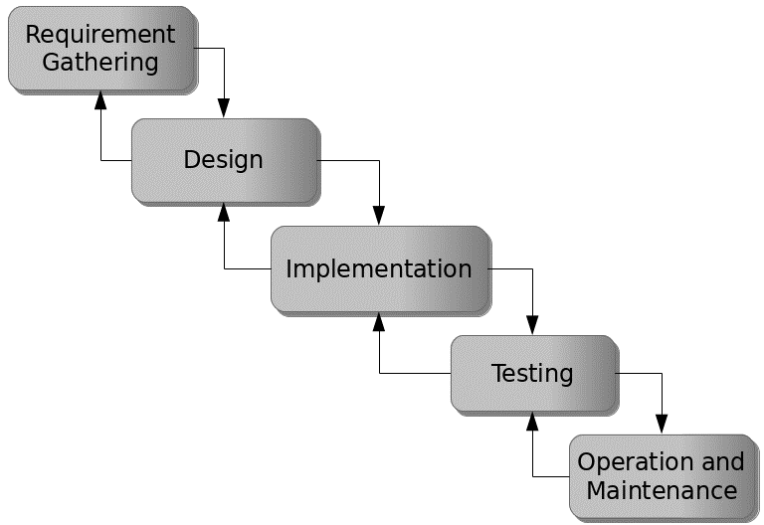

Figure 3.1: Waterfall model

## 3.5 Method of Data Collection

Data collection for the development of the Hotel Reservation system were both primary and secondary sources. Primary sources include direct interactions with stakeholders, such as interviews and surveys, to gather requirements and feedback. Secondary sources encompass existing literature, research, and relevant documentation related to online tutoring platforms and system development.

## 3.6 System Design

System design for the Hotel Reservation system involves defining the platform's architecture, modules, interfaces, and data structures to meet specified requirements. It entails the application of systems theory to product development, ensuring the alignment of design elements with the objectives and needs of the Hotel Reservation system.

## 3.6.1 Algorithm Diagram

**Use case diagram**

A use case diagram shows the system and the various ways that they interact with the system.

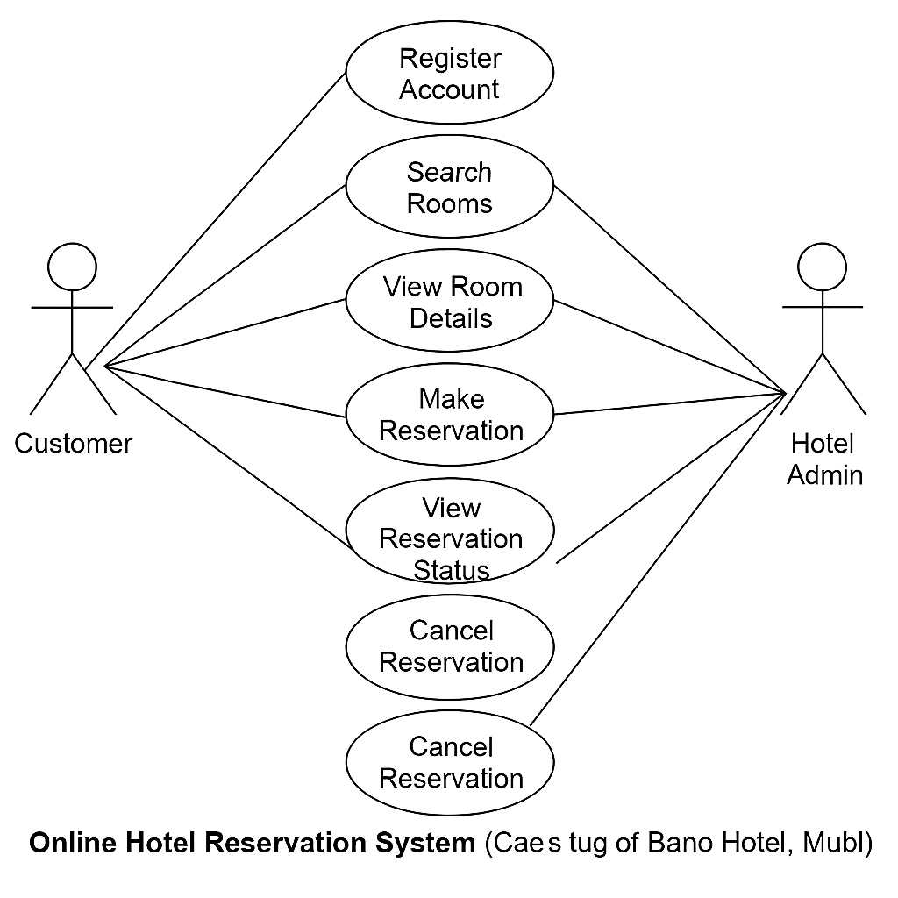

Figure 3.2: Use Case Diagram

**3.6.2 System Architecture**



Database MySQL

Apache Server

**ONLINE HOTEL RESERVATION SYSTEM**

Figure 3.3: System Architecture

## 3.6.3 Database Tables/Queries Structures

The database is used to store all information that pertain the Hotel Reservation records. Below are the database table for the new system.

**Top of Form**

**Table 1: Users Table**

| Name | Type | Extra |
| --- | --- | --- |
| id | int(11) | AUTO_INCREMENT |
| username | varchar(100) |  |
| email | varchar(100) |  |
| phone | varchar(20) |  |
| password | varchar(255) |  |
| user_type | varchar(50) | (admin / guest) |
| date_created | timestamp | DEFAULT CURRENT_TIMESTAMP |

**Table 2: Room Types Table**

| **Name** | **Type** | **Extra** |
| --- | --- | --- |
| id | int(11) | AUTO_INCREMENT |
| type_name | varchar(100) |  |
| description | text |  |
| price | decimal(10,2) |  |
| max_capacity | int(5) |  |

**Table 3: Rooms Table**

| Name | Type | Extra |
| --- | --- | --- |
| id | int(11) | AUTO_INCREMENT |
| room_number | varchar(20) |  |
| room_type | varchar(50) | (single, deluxe) |
| price | decimal(10,2) |  |
| capacity | int(5) |  |
| description | text |  |
| status | varchar(50) | (available/booked) |
| date_created | timestamp | DEFAULT CURRENT_TIMESTAMP |

**Table 4: Bookings Table**

| Name | Type | Extra |
| --- | --- | --- |
| id | int(11) | AUTO_INCREMENT |
| booking_id | varchar(100) |  |
| user_id | int(11) | FOREIGN KEY |
| room_id | int(11) | FOREIGN KEY |
| booking_date | date |  |
| check_in_date | date |  |
| check_out_date | date |  |
| no_of_adults | int(5) |  |
| no_of_children | int(5) |  |
| status | varchar(50) | (pending/confirmed/cancelled) |
| created_at | timestamp | DEFAULT CURRENT_TIMESTAMP |

**Table 5: Payments Table**

| Name | Type | Extra |
| --- | --- | --- |
| id | int(11) | AUTO_INCREMENT |
| booking_id | int(11) | FOREIGN KEY |
| payment_date | timestamp |  |
| amount | decimal(10,2) |  |
| payment_method | varchar(50) | (card, transfer) |
| status | varchar(50) | (paid/pending) |

## 3.6.4 Entity Relationship Modelling

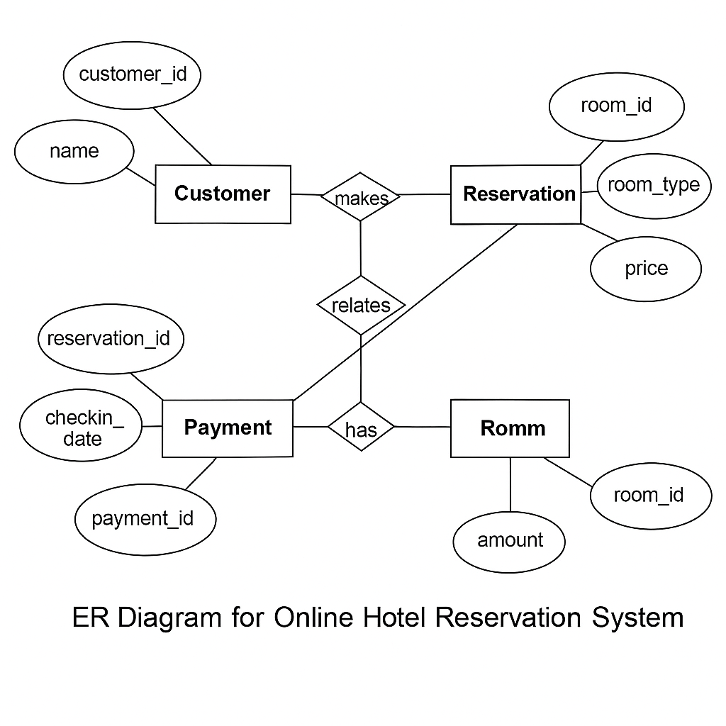

Figure 3.4: Entity Relationship Modelling

## 3.6.5 Database Entity Relationship Diagram

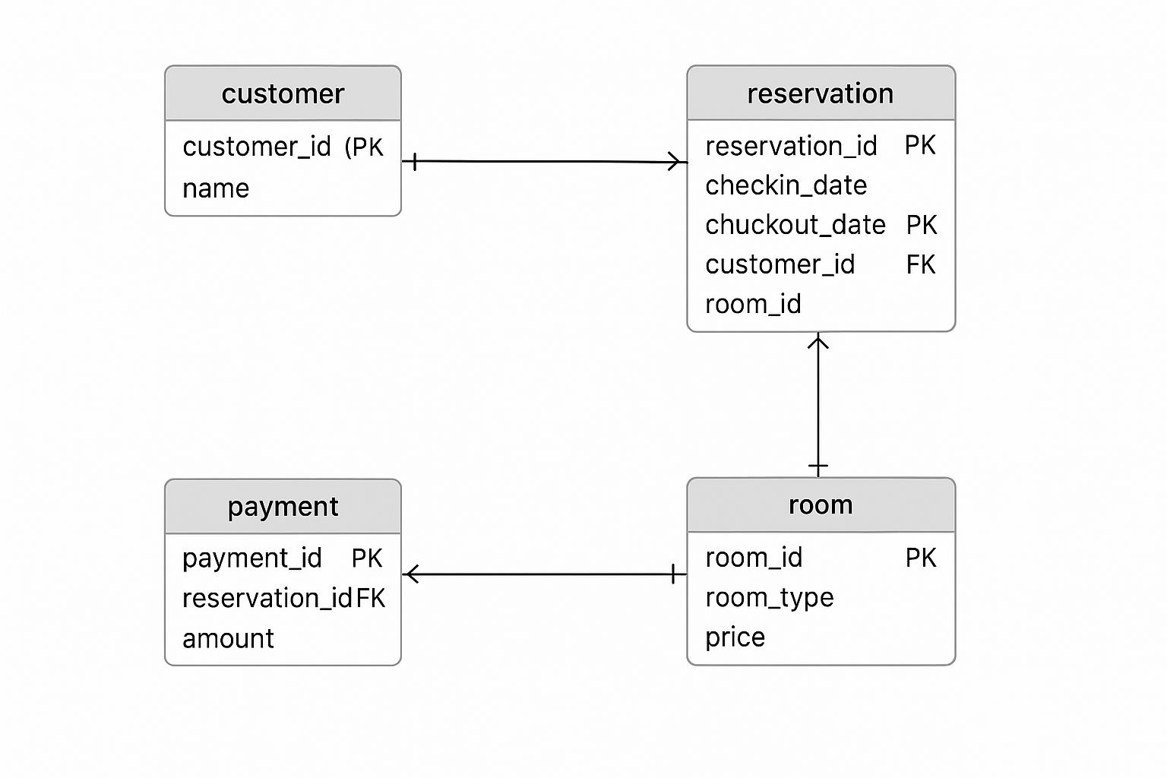

Figure 3.5: Database Entity Relationship Diagram

## 3.6.6 Input and Output Design

**REGISTRATION FORM**

Customer name

Address

**REGISTER**

City

Date of Birth

Phone number

Email

Username

Password

Figure 3.6: Registration Form

**LOGIN FORM**

Username

**LOG IN**

Password

Figure 3.7: Booking Form

**BOOKING FORM**

Check in date

Room type

**BOOK NOW**

Check out date

No. of persons

Figure 3.8: Booking Form

**REGISTRATION FORM**

Check in date

Room type

**BOOK NOW**

Check out date

No. of persons

Figure 3.9: Booking Form

Available room today | Travelers Time

Top of Form



Wing A Travelers Time

Without TV

Number of Person - 2

Remaining Rooms :2

**49500/Night**

Bottom of Form



Figure 3.10: Room Rate

## 3.7 System Requirement Specification

## 3.7.1 Hardware Requirements

The software to be design needs the following hardware for an effective operation of the newly designed system.

1. A system running on intel, P(R) duo core with higher processor
2. The-Random Access Memory (RAM) should be at least 512MB.
3. At least 80-GB hard disk.
4. A monitor.

## 3.7.2 Software Requirements

The software requirements include:

1. A window 7 or higher version of operating system.
2. XAMP or WAMP for Database
3. PHP
4. MySQL
5. Browser

## 3.7.3 Personnel Requirements

Any computer literate who has a technical knowhow of internet surfing can use the system because it is user friendly.

# CHAPTER FOUR

# RESULTS AND DISCUSSION

## 4.1 Introduction

The Online Hotel Reservation System is developed using PHP and MySQL to provide efficient management of hotel bookings and related operations. PHP is used for server-side scripting, enabling the insertion, updating, and retrieval of records from the database with ease. MySQL serves as the backend database management system, securely storing all booking, customer, and room-related data. The system is designed with HTML and CSS for the structure and styling of the website, ensuring a clean and user-friendly interface. JavaScript is used to enhance interactivity, perform real-time client-side validations, and dynamically update content without reloading the entire page.

## 4.2 Results

**4.2.1 Registration interface**

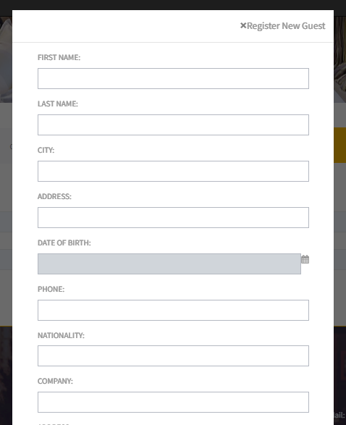

Figure 4.1: Registration interface

Figure 4.1 above shows where the customer can register or create an account in the system using some basic information like the first name, lastname, contact etc.

**4.2.2 Login Interface**

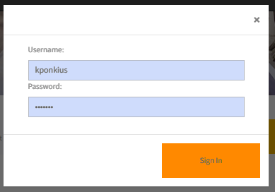

Figure 4.2: Login Interface

Figure 4.2 shows the login page of the system is where a user provides his or her login details (username and password) to gain access to the system.

## 4.2.3 Home page interface

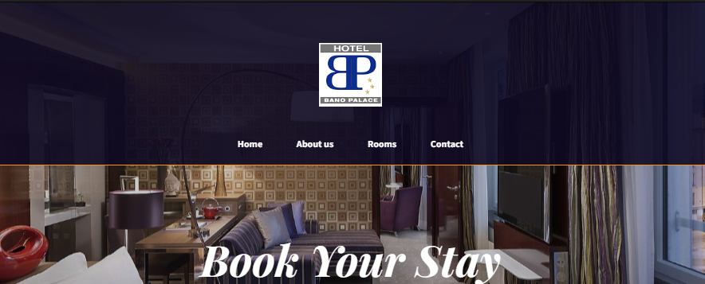

Figure 4.3: Home page interface

Figure 4.3 presents the Home Page Interface of the hotel reservation System. This interface serves as the central landing page for users, offering quick access to essential system features.

**4.2.4 Booking interface**

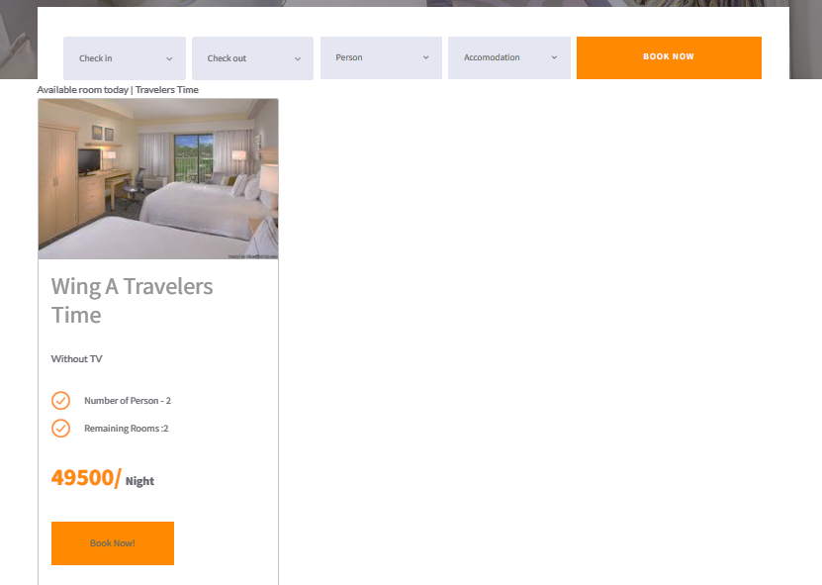

Figure 4.4: Booking interface

Figure 4.4 presents the detailed view of a specific booking. It includes comprehensive information such as the room rate, title, image of the room duration of the reservation, number of guests.

## 4.2.5 Billing interface

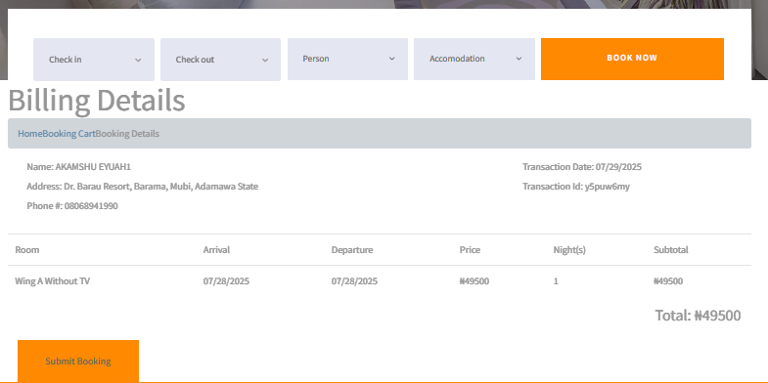

Figure 4.5: Billing interface

Figure 4.5 above shows the billing interface of the billing details for the room such as name of customer and contact details, duration of stay, amount to be paid, transaction id.

**4.2.6 Booking History Interface**

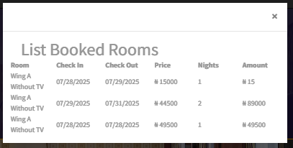

Figure 4.6: Booking History Interface

Figure 4.2 above represents the customer history/records of all bookings made on the system; room name, check in and check out date, price and duration.

**4.2.7 Reservations Interface**

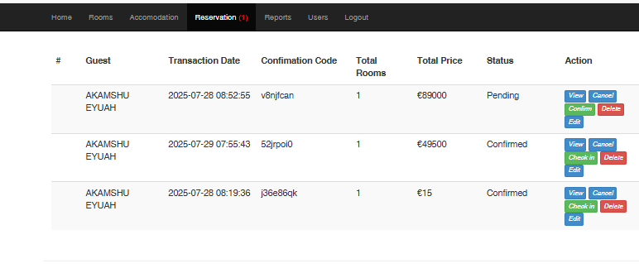

Figure 4.7: Reservations Interface

Figure 4.7: Reservations Interface, shows the interface used by hotel staff to confirm or decline booking reservations made by a customer.

4.2.8 Invoice interface

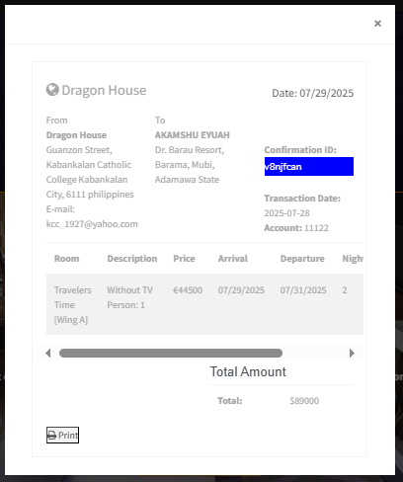

Figure 4.8: Invoice interface

Figure 4.8 shows the invoice interface showing customer details of payment and room paid for upon approval by the hotel management.

## 4.3 Discussion

This section discusses the key interfaces designed and implemented for the Online Hotel Reservation System. Each interface plays a vital role in ensuring smooth navigation, efficient booking management, and a user-friendly experience. The system is structured to allow both customers and hotel staff to interact seamlessly with the platform, as shown in Figures 4.1 to 4.n.

The registration interface (Figure 4.1) enables new users to create an account by providing essential details such as their full name, email address, phone number, and password. The interface also includes validation features to ensure correct data entry. Once registered, users can log in to the system and access booking functionalities. The interface is responsive and user-friendly to encourage more sign-ups.

The login interface (Figure 4.2) provides secure access to registered users by requiring their email/username and password. It incorporates server-side validation to prevent unauthorized access and ensures that only valid credentials can log into the system. A “Forgot Password” link is included to assist users in account recovery.

The home page interface (Figure 4.3) acts as the main entry point after login. It displays hotel information, available rooms, special offers, and navigation menus that lead to booking, reservation history, and account settings. This interface provides a welcoming and informative overview, guiding the user to various system functions.

The booking interface (Figure 4.4) allows customers to search for and reserve hotel rooms based on criteria such as check-in date, check-out date, number of adults, number of children, and room type. It displays available rooms with details including room images, descriptions, prices per night, and capacity. This interface also incorporates real-time availability checking to prevent double-booking.

The billing interface (Figure 4.5) generates a summary of the reservation cost before finalizing the booking. It includes the total number of nights, price per night, taxes, and the final payable amount. The billing details are clearly displayed, allowing customers to confirm payment before proceeding.

The booking history interface (Figure 4.6) displays a record of all past and current reservations made by the user. It includes details such as booking ID, room type, dates of stay, and status (e.g., confirmed, checked-in, or cancelled). This interface helps customers keep track of their travel history with the hotel.

The reservations interface (Figure 4.7) is primarily for hotel staff and administrators. It displays all reservations in the system, including customer details, room numbers, booking status, and payment information. It allows staff to confirm, cancel, or modify reservations as needed.

The invoice interface (Figure 4.8) generates an electronic invoice for completed reservations. It includes all relevant details such as booking ID, customer name, room details, payment amount, and payment date. This interface allows customers to download or print the invoice for record-keeping purposes.

## 4.4 User manual

## 4.4.1 System Installation

The user manual is a clear and precise instruction on how a user can operate the propose system, without any stress and successful. The following steps required

1. Start or boot the computer form the hard disk
2. Double click on the folder that program is been stored in the desktop
3. Double click on the program and allow it to load gently
4. A security unit will display were the user will specify the user name and password the click on OK.
5. A welcome menu will be displayed where the user has options to select which operation to be performed.
6. To find information about player, select any name and search.
7. Click on exist on the welcome screen to exist from the program.

## 4.4.2 System Operational Guide

The following are the necessary steps to take in order to use the system efficiently and effectively.

1. Load the url of the system <https://localhost/hotel/> the welcome page will be displayed.
2. Click on the **Proceed** button to proceed to the main system.
3. If you created an account, provide your login details by entering your username and password.
4. Depending on the login details provided you will be automatically directed to the dashboard.
5. The various task that you can perform on the portal will be displayed on the sidebar of the dashboard.

# CHAPTER FIVE

# SUMMARY, CONCLUSION AND RECOMMENDATIONS

## 5.1 Summary

This project focused on the design and implementation of an Online Hotel Reservation System for Bano Hotel, Mubi to address the inefficiencies of the manual reservation process. The study identified that the existing manual booking process faced significant challenges such as: Booking errors due to miscommunication and poor record keeping, Overbooking caused by lack of real-time room availability updates, Difficulty in retrieving past booking records, leading to poor customer follow-up. The developed system used PHP for server-side processing, MySQL as the database management system, HTML/CSS for the interface, and JavaScript for interactivity. It incorporated key features such as: User registration and login system for secure access, Real-time room availability checking to prevent overbooking, Online booking form that captures booking dates, room preferences, and customer details, Automated billing and invoice generation, Reservation history tracking for both customers and hotel staff, Responsive web design for compatibility across devices.

## 5.2 Conclusion

The Online Hotel Reservation System for Bano Hotel successfully addressed the challenges of the manual system by providing a fast, secure, and reliable platform for booking management. The system benefits both customers and hotel staff: Customers can make bookings anytime, anywhere, and receive instant confirmation. Hotel staff can monitor room availability in real-time, manage reservations efficiently, and generate accurate invoices. The adoption of this system will significantly improve service delivery, enhance customer satisfaction, and reduce operational costs associated with manual booking processes.

## 5.3 Recommendations

Based on the findings, the following recommendations are made:

1. The hotel management should fully implement the system and train all staff members on how to use it effectively.
2. Inform customers about the availability of the online reservation system through social media, flyers, and the hotel’s official website.
3. Future upgrades should include secure online payment options such as PayPal, credit cards, and mobile banking to make the booking process fully automated.
4. Regular updates and maintenance should be performed to keep the system secure, improve performance, and fix any bugs.
5. Implement regular backups to protect against data loss and ensure quick recovery in case of server failures.

# REFERENCES

Gretzel, U., Sigala, M., Xiang, Z., & Koo, C. (2021). Smart tourism: Foundations and developments. *Electronic Markets, 31*(3), 495–509. https://doi.org/10.1007/s12525-020-00450-4

Kumar, A., & Sharma, A. (2020). ICT applications in the hospitality industry: A study of hotels in India. *Journal of Hospitality and Tourism Technology, 11*(1), 93–108. https://doi.org/10.1108/JHTT-03-2019-0032

Law, R., Chan, I. C. C., & Wang, L. (2023). A comprehensive review of the development and usage of e-hospitality systems. *International Journal of Hospitality Management, 108*, 103358.

Nwachukwu, C., & Ayo, C. K. (2021). The influence of internet-enabled devices on travel and hotel booking behavior in Nigeria. *African Journal of Information Systems, 13*(1), 34–51.

Ogbuokiri, B. O., & Okoye, N. O. (2022). Post-COVID-19 adoption of contactless technologies in the Nigerian hospitality sector. *African Journal of Business and Economic Research, 17*(2), 89–105. https://doi.org/10.31920/1750-4562/2022/v17n2a5

Okon, U. J., Udoh, I. A., & Eyo, E. (2022). Evaluation of ICT-based customer service systems in selected Nigerian hotels. *Journal of Tourism and Hospitality Management, 10*(4), 16–29. https://doi.org/10.15640/jthm.v10n4a3

Elmasri, R., & Navathe, S. B. (2019). Fundamentals of Database Systems (7th ed.). Pearson.

Gretzel, U., Sigala, M., Xiang, Z., & Koo, C. (2021). Smart tourism: Foundations and developments. Electronic Markets, 31(3), 495–509.

Kumar, A., & Sharma, A. (2020). ICT applications in the hospitality industry: A study of hotels in India. Journal of Hospitality and Tourism Technology, 11(1), 93–108.

Law, R., Buhalis, D., & Cobanoglu, C. (2020). Progress and trends in e‑hospitality. International Journal of Contemporary Hospitality Management, 32(4), 1235–1259.

Li, X., & Wang, J. (2019). Development of online hotel reservation systems: A review. Journal of Travel Research, 58(7), 1205–1222.

O’Connor, P. J., & Frew, A. J. (2018). Information and Communication Technologies in Tourism. Springer.

Pressman, R. S., & Maxim, B. R. (2021). Software Engineering: A Practitioner’s Approach (9th ed.). McGraw-Hill Education.

Shneiderman, B., Plaisant, C., Cohen, M., Jacobs, S., & Elmqvist, N. (2018). Designing the User Interface: Strategies for Effective Human-Computer Interaction (6th ed.). Pearson.

# APPENDIX A

Registration interface

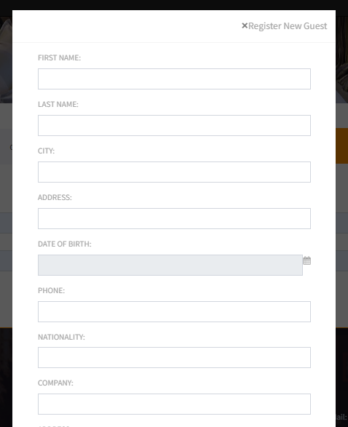

Login Interface

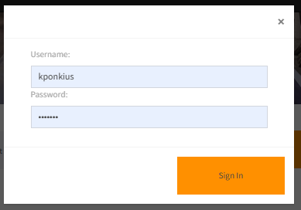

Home page interface



Booking interface

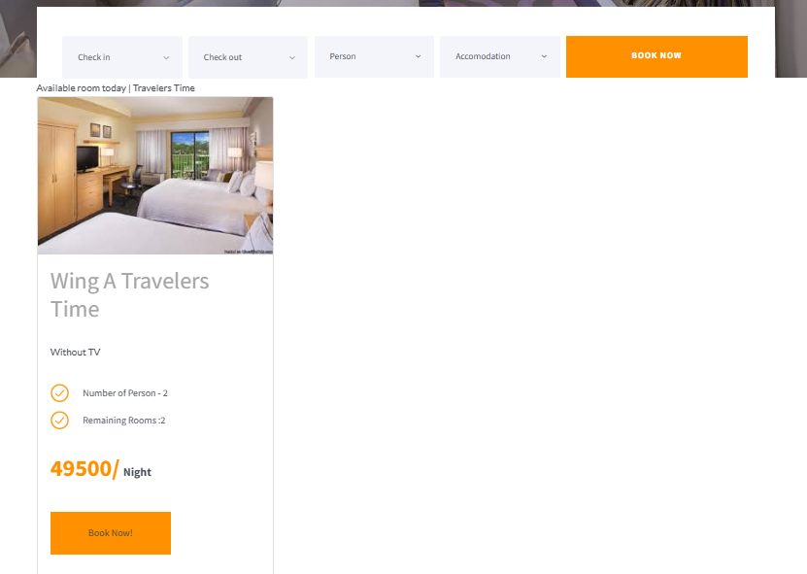

Billing interface

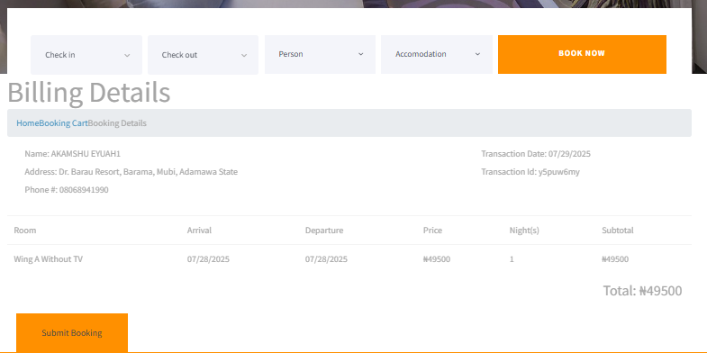

Booking History Interface

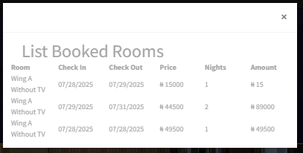

Reservations Interface



Invoice interface



# APPENDIX B

**PROGRAM CODE**

<?php

require "header.php";

?>

<header class="header">

    <div class="row">

        <div class="col-md-12 text-center">

   <a class="logo"><img src="img/logo1.png" alt="logo"></a>

   </div>

        <div class="col-md-12 text-center">

            <button type="button" onclick="window.location.href='reservation.php'" class="btn btn-outline-light btn-lg"><em>Make a Reservation Now!</em></button>

        </div>

    </div>

</header>

<section id="aboutus">

 <div class="container">

   <h3 class="text-center"><br><br>Chocolate & Moer</h3>

   <div class="row">

<!--carousel-->

     <div class="col-sm"><br><br>

        <div id="carouselExampleIndicators" class="carousel slide" data-ride="carousel">

         <ol class="carousel-indicators">

           <li data-target="#carouselExampleIndicators" data-slide-to="0" class="active"></li>

           <li data-target="#carouselExampleIndicators" data-slide-to="1"></li>

           <li data-target="#carouselExampleIndicators" data-slide-to="2"></li>

         </ol>

        <div class="carousel-inner">

           <div class="carousel-item active">

             <img class="d-block w-100" src="img/3.jpeg" alt="First slide">

           </div>

           <div class="carousel-item">

           <img class="d-block w-100" src="img/4.jpeg" alt="Second slide">

           </div>

           <div class="carousel-item">

           <img class="d-block w-100" src="img/5.jpeg" alt="Third slide">

           </div>

        </div>

  <?php

$msg = "";

if(isset($_POST['booknow'])){

    $days =0;

    $day = dateDiff($_SESSION['arrival'],$_SESSION['departure']);

   if($day <= 0){

      $totalprice = $_POST['ROOMPRICE'] *1;

      $days = 1;

    }else{

      $totalprice = $_POST['ROOMPRICE'] * $day;

      $days = $day;

    }

                           <figcaption class="img-title">

                                <h5>'.$result->ROOM . ' <br/> '.$result->ROOMDESC.'  <br/>

                                ' . $result->ACCOMODATION .' <br/>

                                '.$result->ACCOMDESC . '<br/>

                                Number of Person:' . $result->NUMPERSON .' <br/>

                                Price:'.$result->PRICE.'</h5>

                            </figcaption>

                    ';

              }

              }else{

                $btn =  '

                 <div class="form-group">

                        <div class="row">

                          <div class="col-xs-12 col-sm-12">

                            <input type="submit" class="button rooms_button" id="booknow" name="booknow" onclick="return validateBook();" value="Book Now!"/>

                           </div>

                        </div>

                      </div>';

                    $img_title = '

                           <figcaption class="img-title">

                                <h5>'.$result->ROOM . ' <br/> '.$result->ROOMDESC.'  <br/>

                                ' . $result->ACCOMODATION .' <br/>

                                '.$result->ACCOMDESC . '<br/>

                                Number of Person:' . $result->NUMPERSON .' <br/>

                                Price:'.$result->PRICE.'</h5>

                            </figcaption>

                    ';

              }

//

                ?>

                 <form method="POST" action="index.php?p=accomodation">

                 <input type="hidden" name="ROOMPRICE" value="<?php echo $result->PRICE ;?>">

                  <input type="hidden" name="ROOMID" value="<?php echo $result->ROOMID ;?>">

                      <div class="card">

                        <img class="card-img-top"  src="<?php echo WEB_ROOT .'admin/mod_room/'.$result->ROOMIMAGE; ?>" alt="Room image description">

                        <div class="card-body">

                          <div class="rooms_title"><h2><?php echo $result->ROOM ;?> <?php echo $result->ACCOMODATION ;?></h2></div>

                          <div class="rooms_text">

                            <p><?php echo $result->ROOMDESC ;?></p>

                          </div>

                          <div class="rooms_list">

                            <ul>

                              <li class="d-flex flex-row align-items-center justify-content-start">

                                <img src="images/check.png" alt="">

                                <span>Number of Person - <?php echo $result->NUMPERSON ;?></span>

                              </li>

                              <li class="d-flex flex-row align-items-center justify-content-start">

                                <img src="images/check.png" alt="">

                                <span>Remaining Rooms :<?php echo  $resNum ;?></span>

                              </li>

                            </ul>

                          </div>

                          <div class="rooms_price"><?php echo   $result->PRICE ;?>/<span>Night</span></div>

                           <?php echo $btn ; ?>

                        </div>

                      </div>

                  </form>

                <?php

                 }

                ?>

              </div>

          </div>

 </div>